**Assignment 6.1.2**

**Find out the number of people undertaken the trips from the places MIA and HOU**

**Input Text Data:**

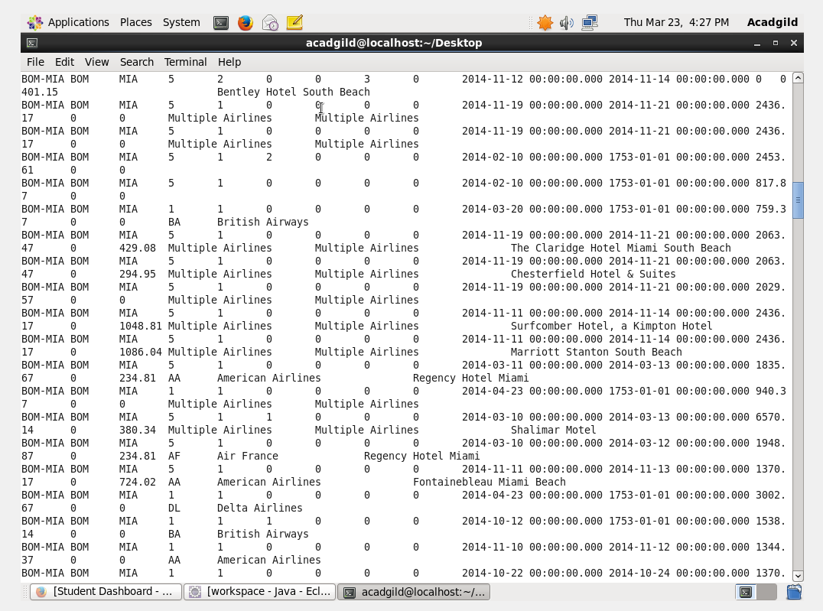

**Task Driver:**

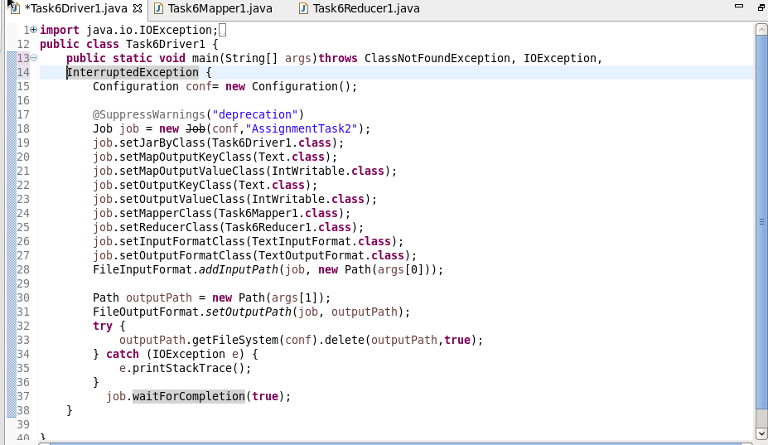

**Task Mapper:**

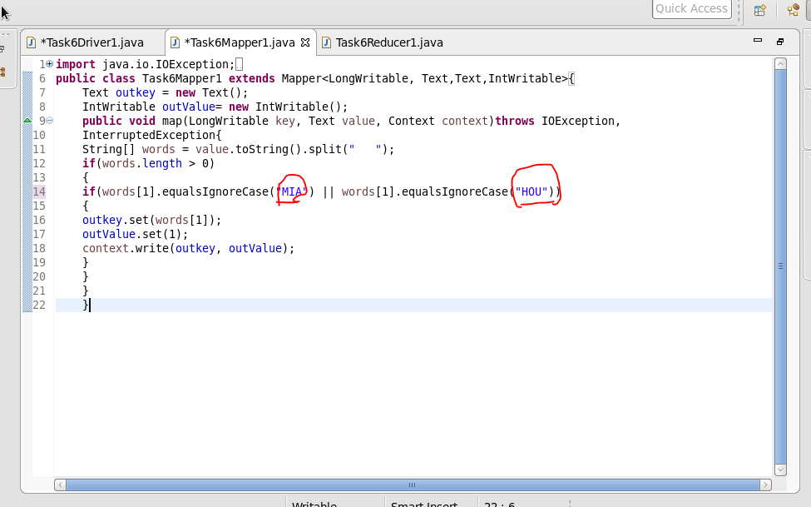

**Task Reducer:**

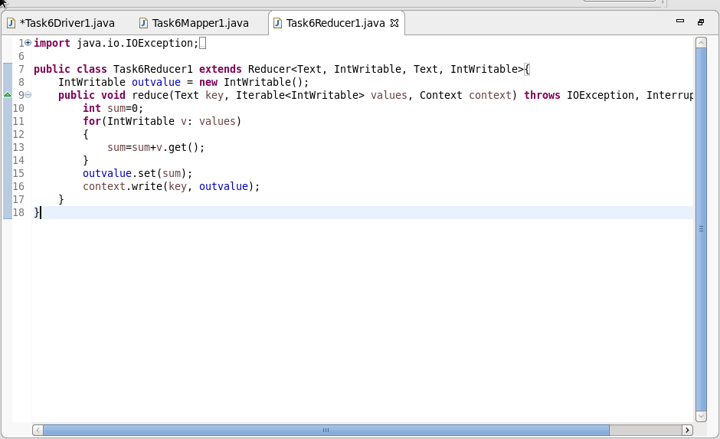

**Output:**

